

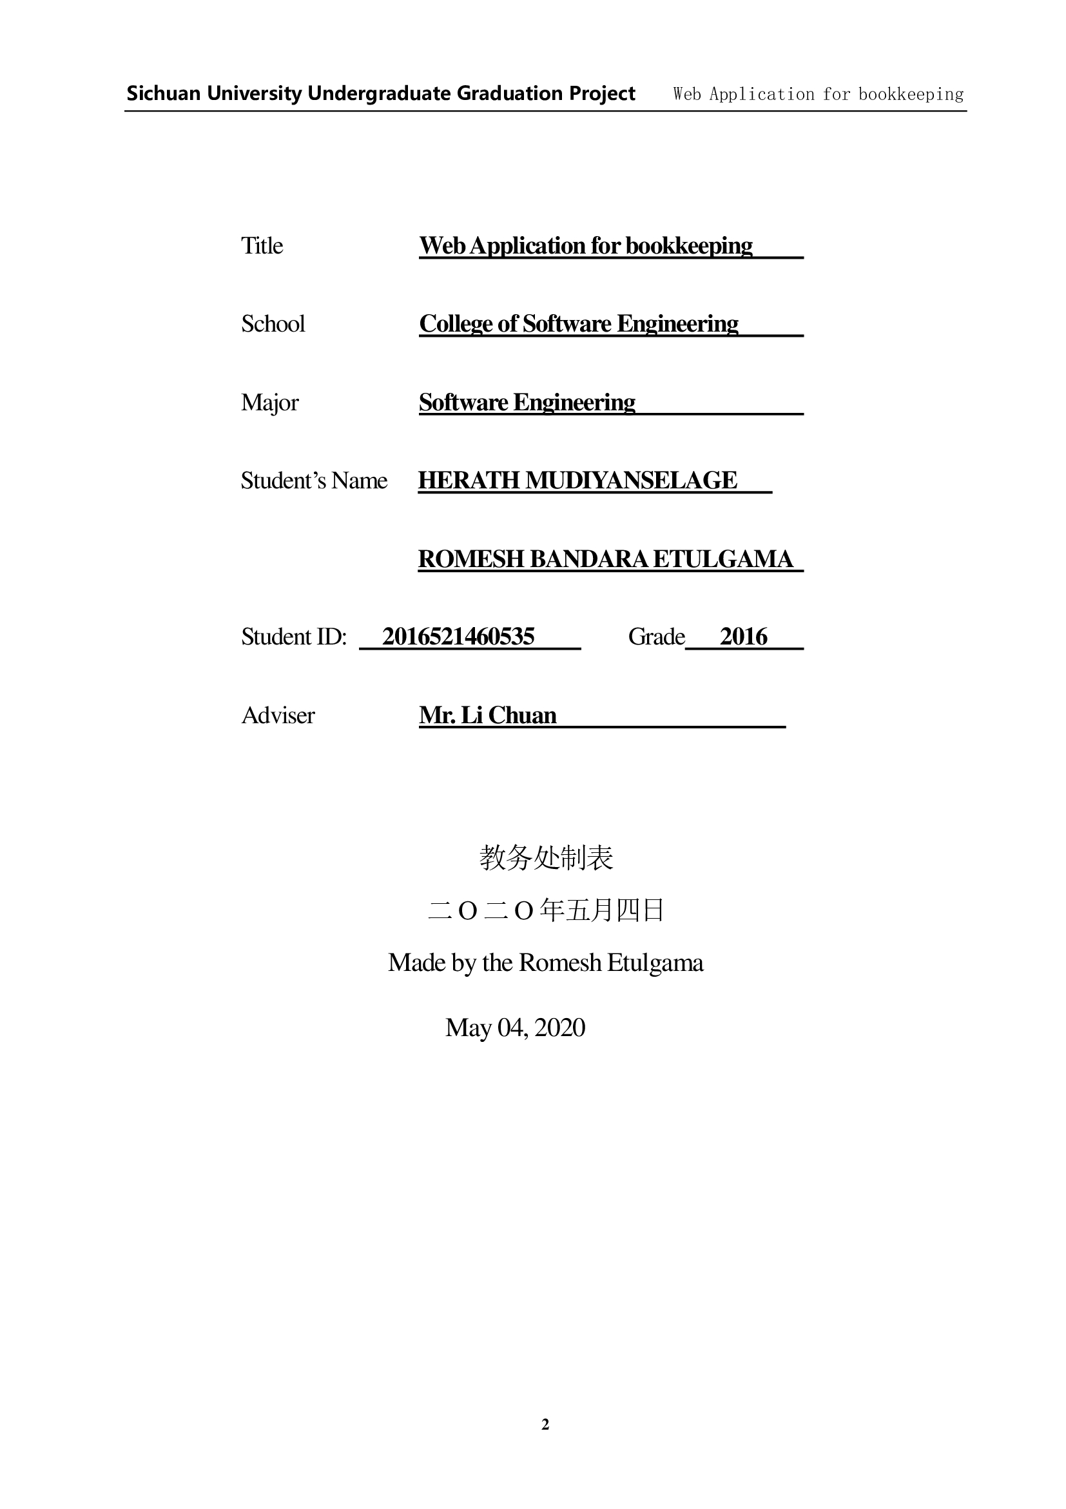

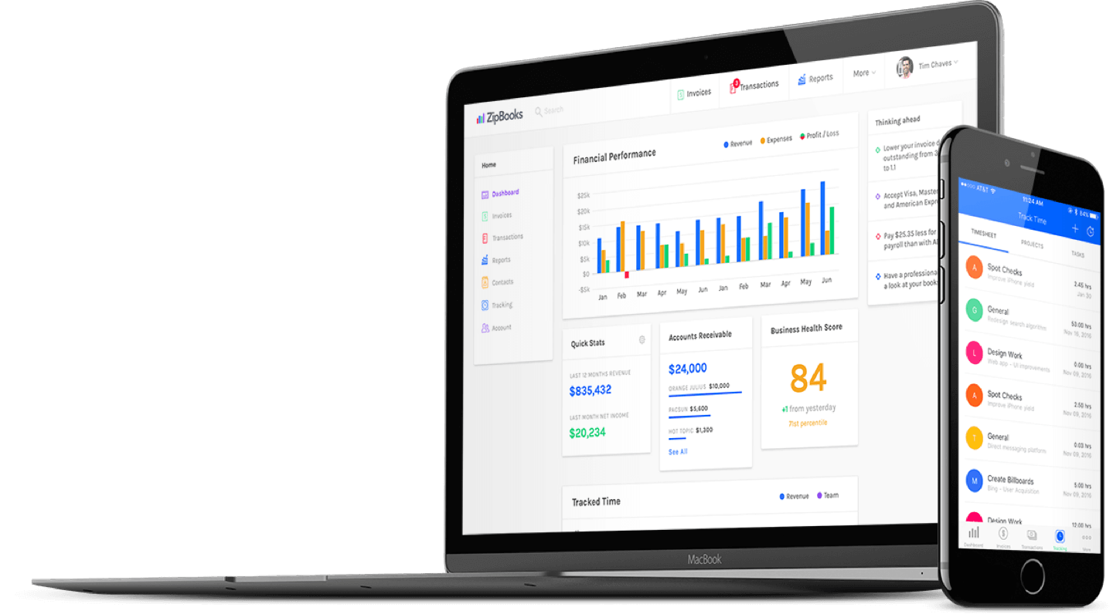



BOOKKEEPING web APPLICATION

Romesh Etulgama (2016521460535)

| Capstone Project |

Under supervision of Mr. Li Chuan

Software Collage - SICHUAN UNIVERSITY

26-04-2020

# Abstract

This report describes the project development of the Bookkeeping web application, "Quentin" that was developed to manage the daily transactions and manage the clients, inventories, sales and accounts more efficiently. This application is mainly used by the clerks, managers and the CEO of the company. A clerk is able to manage the suppliers, inventories, production, sales and financial transactions in the company as well as the factory itself. Besides that, the application allows the user to generate various kinds of reports such as client information, historical reports plus reliable forecasts to help the entrepreneurs make better decisions.

The methodology I used to develop this system is waterfall model. Thus, the report's chapters include system planning, requirement analysis, system design, programming, system testing, and evolution of the project. For the system planning, the outcomes are the project objectives and project aim as well as to define the project scope. Requirement analysis is a stage to gather the user requirements such as functional requirements and non-functional requirements. Next the system design is mainly used to design the user interface and the database design. The next stage after system design is programming stage. This is the stage for coding. After completion of the coding part, I proceeded to the system testing to minimize the bugs in the systems.

Compared to the existing manual methods used by the target company, this system has many strengths and fairly small amount of weaknesses such as requirement of general computer literacy. In the future, we can enhance the system with smart technologies to make it better.

Keywords: Bookkeeping, Accounting, Management, Small Businesses,

# Acknowledgements

After completing my capstone project, I would like to take this chance to express my sincere gratitude to my project supervisor Mr. Li Chuan who has guided me a lot throughout the project development.

Lorem ipsum dolor sit amet, consectetuer adipiscing elit. Maecenas porttitor congue massa. Fusce posuere, magna sed pulvinar ultricies, purus lectus malesuada libero, sit amet commodo magna eros quis urna. Nunc viverra imperdiet enim. Fusce est. Vivamus a tellus. Pellentesque habitant morbi tristique senectus et netus et malesuada fames ac turpis egestas. Proin pharetra nonummy pede.

Mauris et orci. Aenean nec lorem. In porttitor. Donec laoreet nonummy augue. Suspendisse dui purus, scelerisque at, vulputate vitae, pretium mattis, nunc. Mauris eget neque at sem venenatis eleifend. Ut nonummy. Fusce aliquet pede non pede.

Suspendisse dapibus lorem pellentesque magna. Integer nulla. Donec blandit feugiat ligula. Donec hendrerit, felis et imperdiet euismod, purus ipsum pretium metus, in lacinia nulla nisl eget sapien. Donec ut est in lectus consequat consequat. Etiam eget dui. Aliquam erat volutpat. Sed at lorem in nunc porta tristique.

Proin nec augue. Quisque aliquam tempor magna. Pellentesque habitant morbi tristique senectus et netus et malesuada fames ac turpis egestas. Nunc ac magna. Maecenas odio dolor, vulputate vel, auctor ac, accumsan id, felis. Pellentesque cursus sagittis felis. Pellentesque porttitor, velit lacinia egestas auctor, diam eros tempus arcu, nec vulputate augue magna vel risus. Cras non magna vel ante adipiscing rhoncus.

Table of Contents

Abstract 3

Acknowledgements 4

1.0 System Planning 1

1.1 Project Aims and Objectives 1

1.2 Background of the project 1

1.3 Project Scope 2

1.3.1 Milk Collection 4

1.3.2 Employee Management 5

1.3.3 Inventory Management 7

1.3.4 Sales Tracking 8

1.4 Project Schedule 10

1.5 Outline of approach / Methodology Used 11

1.5.1 Development Environment 12

1.6 Operation Environment 13

1.7 Chapter 1 Conclusion 13

2.0 Requirement Analysis 15

2.1 Software Requirement Specification (SRS) 15

2.1.1 General Description 15

2.1.2 System Objectives 16

2.1.3 System Requirements 16

2.2 Chapter 2 Conclusion 49

Chapter 1

**System Planning**

# System Planning

The development process of the system will be discussed in this chapter as well as the system objectives, scope and schedules.

## 1.1 Project Aims and Objectives

The project aims and objectives that will be achieved after completion of the system are discussed here. The succession of the system will also be evaluated through this sub chapter.

The project objectives are:

* To eliminate/reduce the paper work in the company
* To record every transaction in computerized system so that problems occur by human error can be greatly reduced
* To implement smart technologies to the system
* To design a user-friendly graphical user interface which suits the users
* To complete the system according to the project schedule
* To produce technical reports that documents the phases, tasks and deliverables in the project

## 1.2 Background of the project

"Quentin" is a management system developed geared mainly toward small and medium-sized businesses and offer cloud-based accounting and management applications that handle the primary bookkeeping functions of a company and manage payments and payroll functions, manage asset collections, track distribution, manage relationships with their clients and more importantly to make predictions on sales.

This application is designed and implemented for a candy manufacturing company in Sri Lanka. It is a medium sized enterprise based in a rural area of the country. Most of the design aspects of the Quentin system is focused on the requirements of this particular company. The company use Cow's Milk and Sugar as the raw materials of the manufacturing process (figure 1).

Milk is collected from the rural milk suppliers, twice every day. Collection happen at the factory premises for some supplies, as well as at supplier's own farm premises by employees of the company. Usually, around 500 liters of milk is collected every day from around 40 suppliers.

Sugar is purchased from an importer and gets delivered to the factory premises.

Manufacturing process takes place by around 20 workers and some machinery, usually around 10 hours a day, 5 days of the week. Manufactured candy is called "Milk Toffee" and after the quality controlling is passed, they are packaged. The custom designed packages are purchased from a printing company which takes at least 2 weeks to deliver the empty packages after an order is placed. Therefore, it is crucial for the company to foresee the upcoming requirement and manufacturing capacity of the factory so that they can have a hassle-free workflow.

The manufactured products are then delivered to both distribution agents as well as distributed to some outlets by the company itself. Usually, the money is collected once they deliver, but some clients prefer to transfer the money to the bank or paid by a credit cheque. Therefore, the company needs to maintain an outstanding balance for individual clients.

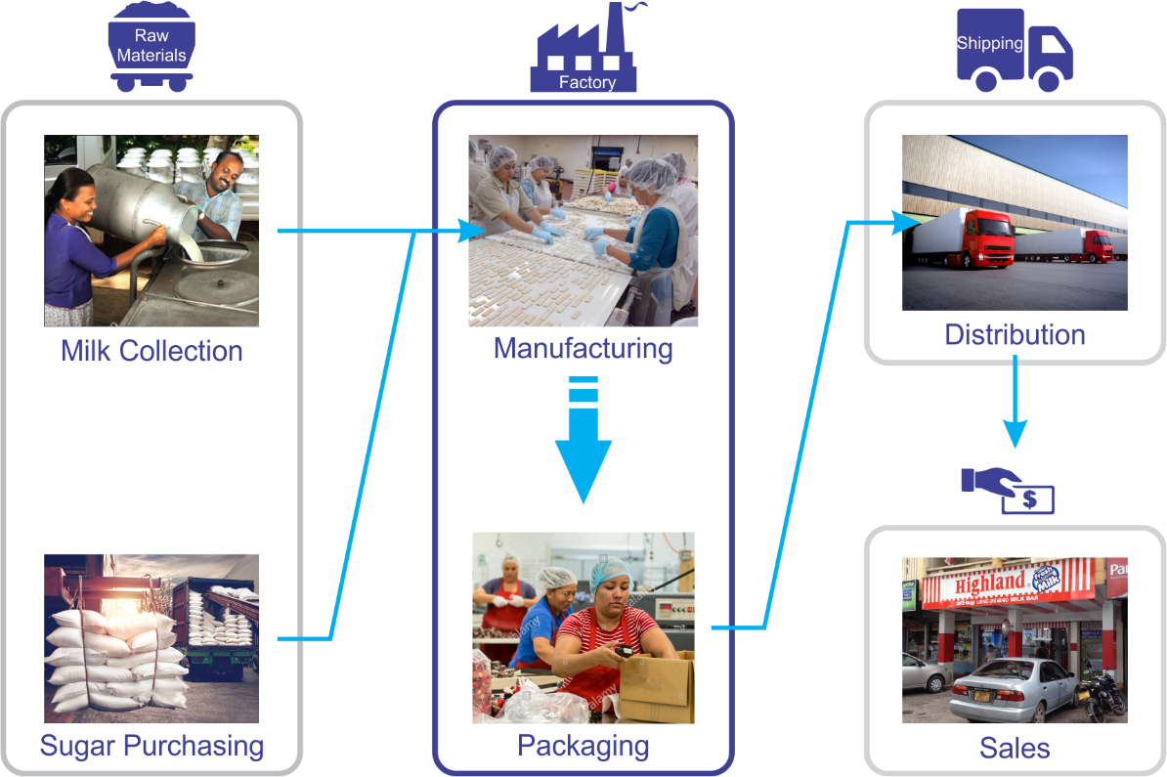

Figure 1 : Company Workflow

This application is mainly used by the clerks, managers and the CEO of the company. A clerk is able to manage the suppliers, inventories, production, sales and financial transactions in the company as well as the factory itself. Besides that, the application allows the user to generate various kinds of reports such as client information, historical reports plus reliable forecasts to help the entrepreneurs make better business decisions.

Since all of the calculations, report generation and the ability to check real-time status makes the work of the users much easier narrowing down the entirety of their workload into just recording the correct data.

## 1.3 Project Scope

The modules contained inside the bookkeeping application will be discussed below.

For the "Quentin" system, it has a web application as the front-end user interface while the back-end of the system takes care of the data validation and database management on the server.

The modules can be divided into some categories as they serve for each purpose within the system. (figure 2)

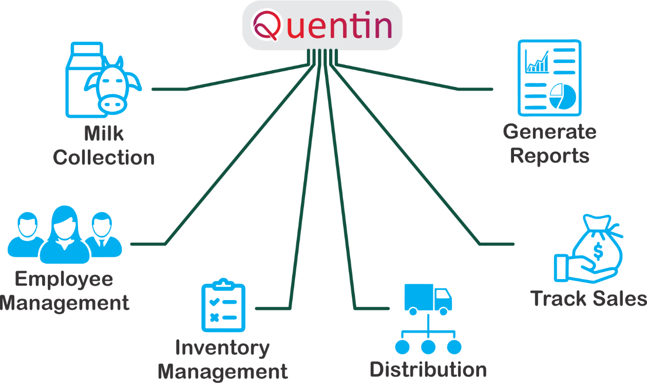

Figure 2 : Tasks handled by Quentin

**Milk Collection** – keeps track of collected milk volume from each supplier as well as generate reports so that the user can examine the trends for the near future of the milk supply.

**Employee Management** – there are four basic classes of workers employed in the company. Factory workers, Drivers, Milk Collectors and Salesmen. Each class has their own salary grade scale while each employee in a group may have its own method of calculation according to their seniority.

**Inventory Management** – purchased items including electricity, water, gas, raw materials and manufactured products are recorded in this module.

**Distribution** – This module takes care of route planning so that the delivery vehicles can have an efficient distribution and meet an exceptional result which will be discussed later in the document.

**Sales Tracking** – A profile for each client is generated in order to track their sales

**Report Generation** – All sorts of useful information is represented by the reports from daily scope to yearly scope as well as for individual aspects.

Beside the above listed modules, some other mandatory modules are also being used but I am not going to explain them much since they are common in applications like this.

#### Authorization and authentication module

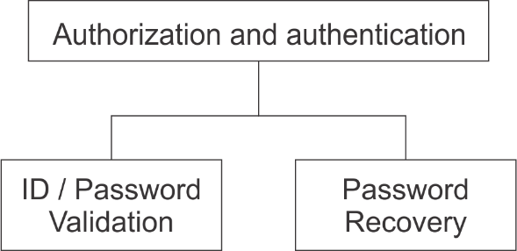

Figure 3 : Authorization and authentication module

Anyone willing to access the website needs to go through this module. They need to login to the system using their id and password. Various users can access the different modules when logged in successfully. For example, only admin level users are able to access the report module.

### 1.3.1 Milk Collection

Milk collectors goes to the milk suppliers and farms twice every day. The collected milk containers are brought back to the factory, measured and quality is tested in factory then the results are recorded on a note book. That data is then fed to the Quentin system every 15 days. The system generates a summary report for the time period (typically 15 days), a receipt confirmation chart (to be signed from the supplier), a payment breakdown chart (to be handed over to the supplier).

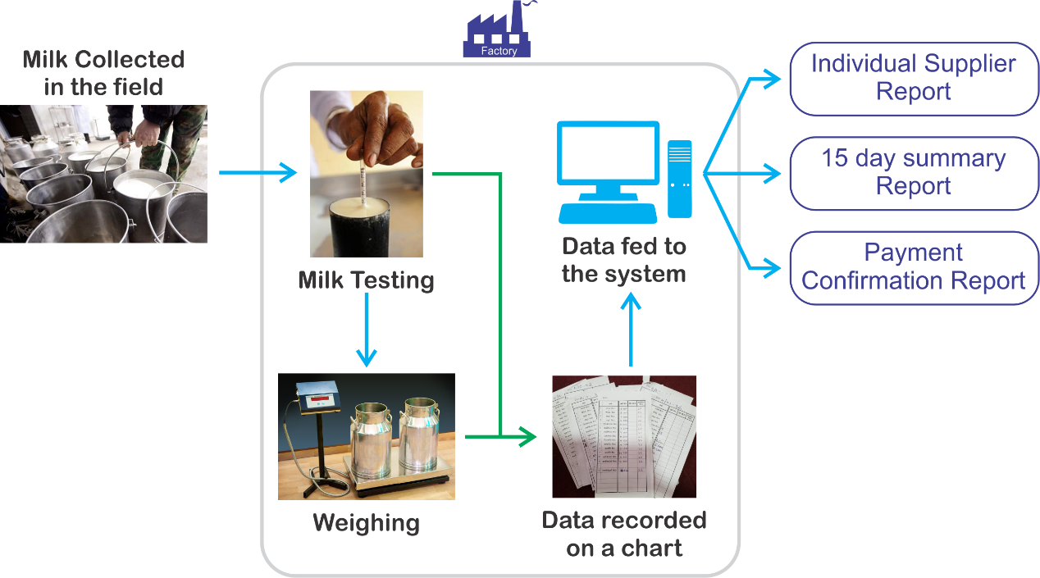

Figure 4 : Milk Collection Process

#### Supplier Management Module

This module can be accessed by anyone but only the admin level users can restore, view and access the supplier history. Milk supplier details are stored to the system via this module.

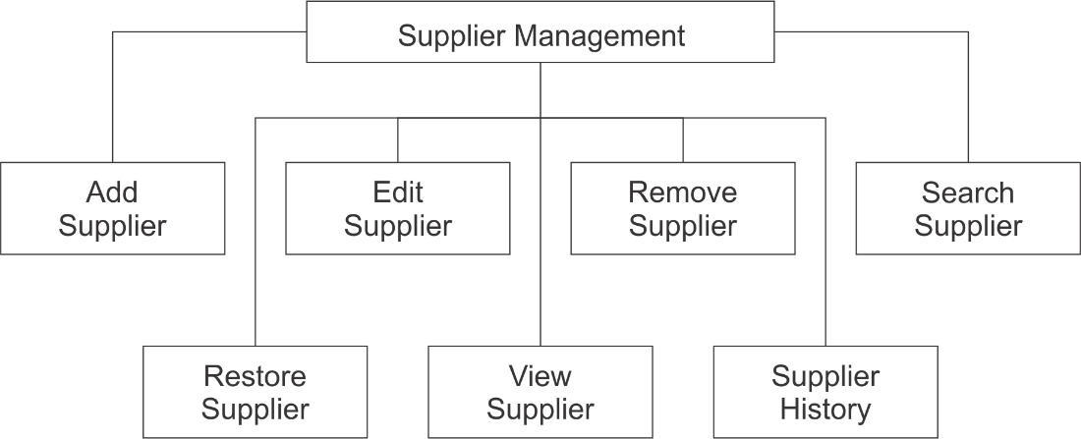

Figure 5: Supplier Management Module

#### Collection entry module

This module can be accessed by everyone from all levels. This module is used to maintain the milk collection records. This module is used to record the data from the daily collection table.

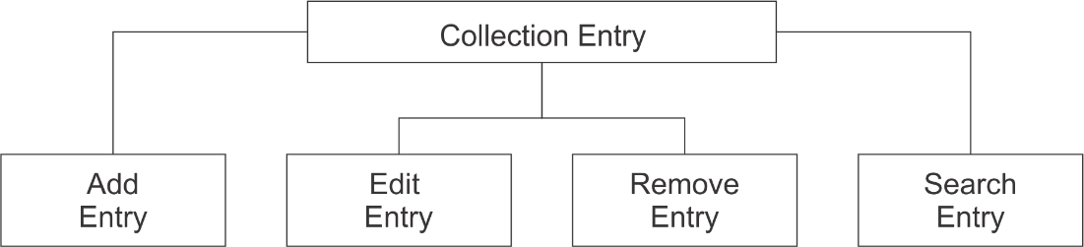

Figure 6: Collection entry module

### 1.3.2 Employee Management

Main part of the employee management is to record the daily admission times of the employees. Factory workers arrive and leave at varying times while having a midday short break. These times are recorded on a book and that data is fed to the system weekly. The system calculates the number of hours a worker has worked and calculates the salary according to the pay grade. The other classes of employees have their own pay grades; therefore, each class has their own calculation method and data entry interface. The system generates a pay sheet, and monthly reports at the end.

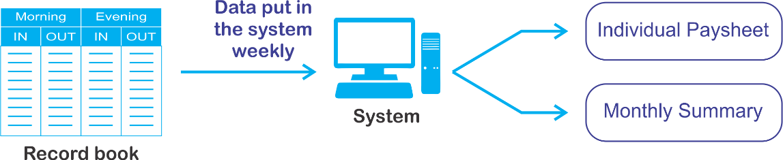

Figure 7: Class I employee salary calculation process

#### Employee Management Module

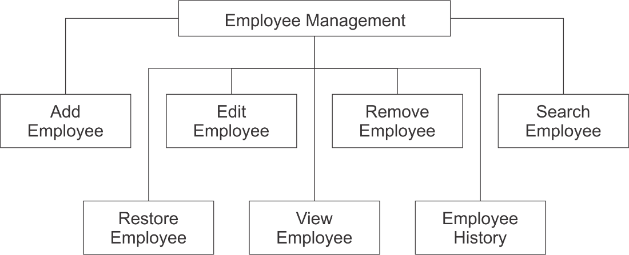

Figure 8: Employee Management Module

This module can be accessed by anyone but only the admin level users can restore, view and access the employee history. Employee details are stored to the system via this module.

#### Admission Record Module

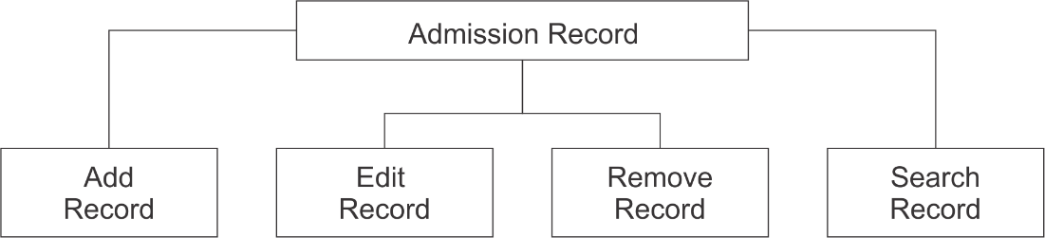

Figure 9: Admission Record

This module can be accessed by everyone from all levels. This module is used to maintain the employee admission records. This module is used to record the data from the daily admission record book.

### 1.3.3 Inventory Management

The system needs to record the purchases of goods/ items/ services in order to manage the production and make predictions. The goods/ items usually are sugar, fuel, packaging materials, polythene, gas and the services are electricity and water.

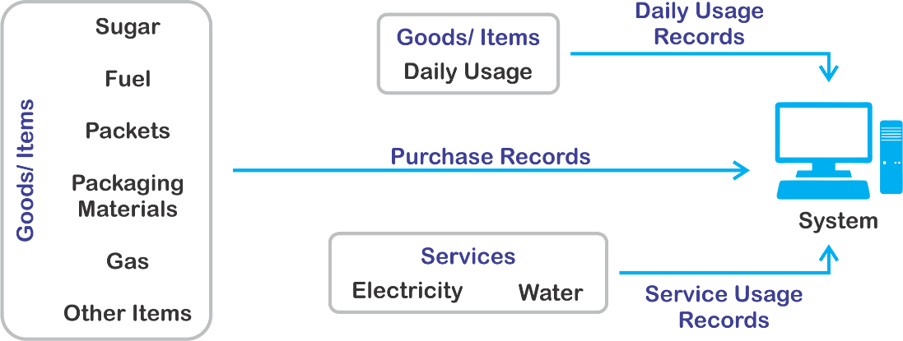

Figure 10: Inventory Management Process

#### Purchase Record Module

This module can be accessed by anyone but only the admin level users can view and access the purchase history. Purchase details are stored to the system via this module.

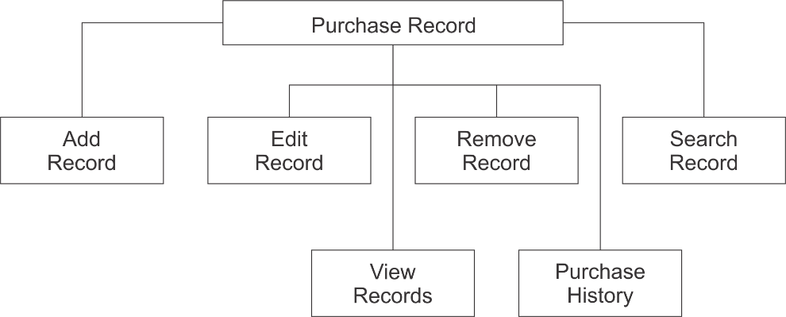

Figure 11: Purchase Record Module

#### Services Usage Record Module

This module can be accessed by anyone but only the admin level users can view and access the usage history. Services usage details are stored to the system via this module.

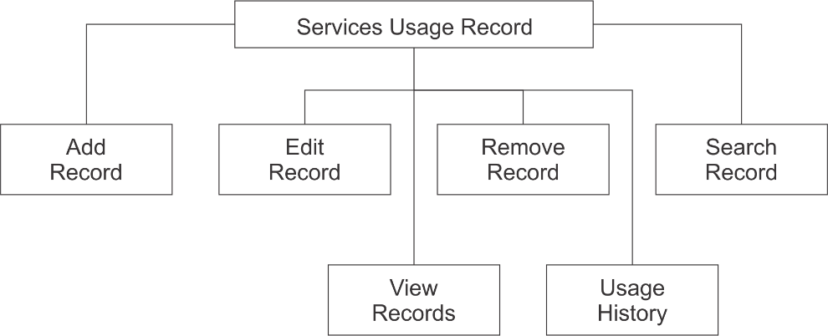

Figure 12: Usage Record Module

#### Daily Usage Record Module

This module can be accessed by anyone but only the admin level users can view and access the usage history. Daily usage details are stored to the system via this module.

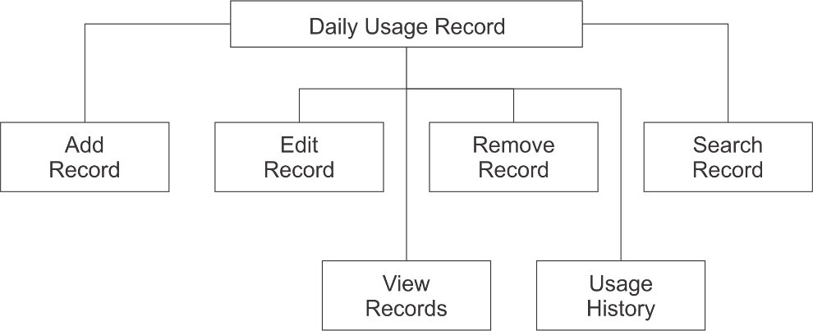

Figure 13: Daily Usage Record Module

### 1.3.4 Sales Tracking

#### Client Management Module

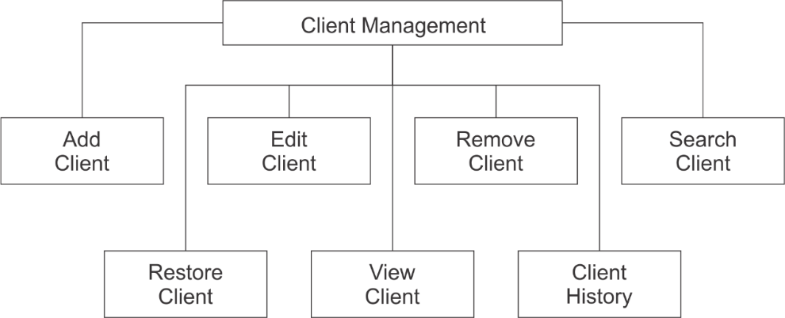

Figure 14: Client Management Module

This module can be accessed by anyone but only the admin level users can restore, view and access the client history.

#### Product Management Module

This module can be accessed by everyone from all levels. This module is used to maintain the product list.

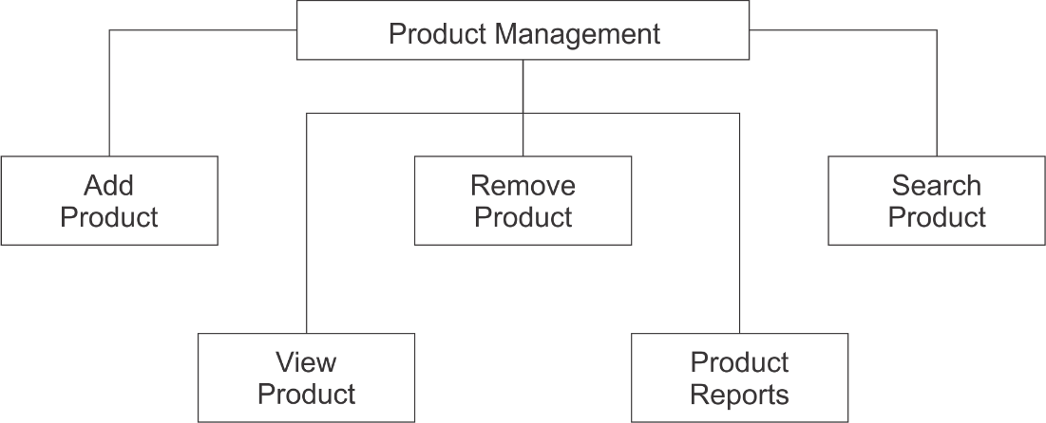

Figure 15: Product Management Module

#### Payment Module

Everything can add, edit, remove and view payment records but only the admin level users can view and generate payment reports.

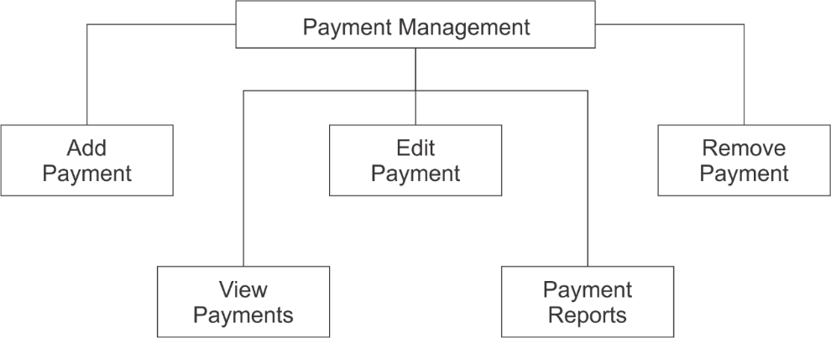

Figure 16: Payment Module

#### Invoice Management Module

This is one of the most advanced modules in the project.

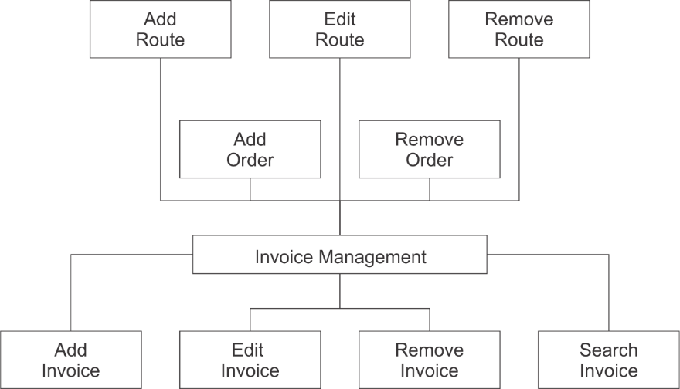

Figure 17: Invoice Management Module

This module is used to add, edit or remove routes which specifies the delivery route of the orders contained inside. Each route will have multiple orders on different dates holding multiple Order numbers. Each order will contain many invoices, which falls under the same order number but assigned for different clients. The database structure of this process is described later in the document. Removing an order is only available for the admin level user.

## 1.4 Project Schedule

Gantt Chart

## 1.5 Outline of approach / Methodology Used

The software/ services used for the development of the application is listed below (see Table 1). On the other hand, the methodology I used to develop this is waterfall model.

|  |  |
| --- | --- |
| **Software / Service** | **Purpose** |
| Visual Studio Code 1.44.2 | For front-end and back-end development using PHP, JavaScript, CSC and HTML |
| MySQL server 8.0 | Database service |
| JetBrains DataGrip 2018.2.5 | For MySQL server management and database manipulation |
| XAMPP Control Panel | For implementation of the local server |
| GitHub | Whole project is stored in GitHub for the ease of development |

Table 1: Software / Services used in development

Waterfall model is one of a system development life cycle (SDLC) model. Developer proceed to next phase if and only if the current phase is complete just like water in a waterfall always fall down, but never goes upward. In Royce's original waterfall model, it originally consisted of 7 phases which are Requirement Specification, Design, Construction, Integration, Testing and Debugging, Installation and Maintenance.

First, I visited the said company and discussed and understood the requirements of the application while taking input from the clients and integrating them with my opinions and ideas. After a sufficient requirement speciation is constructed, the next phase is the design phase.

This consists of user interface design and database design. The interface design is somewhat challenging because as per the requirement specification, the application has to replace the existing management models used in the company with least modifications, thus making it easier for the company to assign existing clerks and managers to use the application with a very small training curve. Database design was straightforward once the requirements are analyzed carefully.

Next, the construction phase was one of the most important and time-consuming phases given the programmer's abilities. The programmer's experience in web development was fairly new, thus causing considerable amount of time although the logic and the processes of the application was well understood.

The integration phase was for integrating the UI with the database. A mobile application was suggested before in the design phase but it was dropped later in the integration process.

After the integration came the testing and debugging phase. For testing module, it is separated into few types which are module testing, system testing, unit testing and user acceptance test. Once there is a bug found, it was immediately fixed/ solved before the system is launched in order to ensure the launched system is bug free.

Lastly, the system was initiated on a public server and the database had to be populated with existing data in order to speed up the learning process. After the initialization, the system maintenance is constant requirement since this is a web application and the communication between the browser and server can sometimes not work as expected.

In my opinion, the time spent on earlier phases of SDLC can lead to greater economy in later stages. In earlier phases, a bug can be fixed in short time with less cost and much flexibility and less effort compared to later phases.

### 1.5.1 Development Environment

#### Software

##### Operating System: Windows 10

##### Database: MySQL

MySQL is an open-source relational database management system.

##### Development tools and programming languages

Visual Studio Code: Visual Studio Code is a source-code editor developed by Microsoft. It includes embedded Git and support for debugging, syntax highlighting, intelligent code completion, snippets, and code refactoring.

XAMPP: XAMPP is a free and open-source cross-platform web server solution stack package, consisting mainly of the Apache HTTP Server, MariaDB database, and interpreters for scripts written in the PHP and Perl programming languages.

GitHub: GitHub is a Git repository hosting service, but it adds many of its own features. While Git is a command line tool, GitHub provides a Web-based graphical interface. It also provides access control and several collaboration features, such as a wikis and basic task management tools for every project.

HTML: Hypertext Markup Language is the standard markup language for documents designed to be displayed in a web browser. It can be assisted by technologies such as Cascading Style Sheets and scripting languages such as JavaScript.

PHP: PHP is a popular general-purpose scripting language that is especially suited to web development.

JavaScript: JavaScript, often abbreviated as JS, is a programming language that conforms to the ECMAScript specification. JavaScript is high-level, often just-in-time compiled, and multi-paradigm. It has curly-bracket syntax, dynamic typing, prototype-based object-orientation, and first-class functions.

CSS: Cascading Style Sheets is a style sheet language used for describing the presentation of a document written in a markup language like HTML. CSS is a cornerstone technology of the World Wide Web, alongside HTML and JavaScript

##### Hardware

##### Processor

Intel Core i5-6200U

##### Ram

8 GB

## 1.6 Operation Environment

Since this application runs in the web browser, the minimum requirements for the application are similar to the requirements of a latest web browser. Chrome web browser is suggested for using the application.

Google Chrome will run on computers equipped with a Pentium 4 processor or higher, which encompasses most machines manufactured since 2001. The computer must have approximately 100MB of free hard drive space and 128MB of RAM.

An internet connection is required to access the web application.

## 1.7 Chapter 1 Conclusion

In chapter 1, the project background, project schedule, project scope, methodology used and the development and operating environment are discussed.

Since this application was developed for a target company, some minor problems had to be faced during the system planning because the developer did not have total freedom in deciding how the system should work. Therefore, the system has some company specific functionalities which are not common among other similar applications.

Although the waterfall model was used, it caused some problems while integrating the user interface with the backend of the system due to poor coding practices. Therefore, the communication linkage had to be modified along with the back-end development process.

Making some necessary changes and modifications are suggested during the development process without just blindly following the chosen methodology in order to ease the process while minimizing the error.

Chapter 2

**Requirement Analysis**

# Requirement Analysis

In this chapter, Software Requirement Specification (SRS) and Data Flow Diagram (DFD) of the application will be discussed and analyzed. The functional and non-functional requirements are included in SRS to provide complete description and overview of system requirement before the development of the process is carried out. Besides that, DFD provides a view of how the system or data is flowed in order to increase the efficiency and effectiveness to achieve system objectives.

## 2.1 Software Requirement Specification (SRS)

### 2.1.1 General Description

#### Product Description

Quentin is a computerized system and a web application designed for bookkeeping purposes which can help the users (clerk, managers and CEOs of a company) to manage and process daily activities of the company and take decision base on analytical data in electronic format. It reduces the risk of paper work such as loss of files, damaged files due to environmental reasons, less accuracy and huge time consumption. The system helps the user to manage the traditional bookkeeping workload more effectively and efficiently.

#### Problem Statement

The problems occurred before having a computerized system includes:

* **Loss of files**

Before the computerized system was implemented, rarely used files tended to be lost due to hardships of physical storage and management caused by human and environmental reasons. Sometimes, the clerk could not keep track of the records and involved in many human errors.

* **Damaged Files**

Files can be damaged by accident, due to old age and environmental reason.

* **Difficulty to search and organize records**

Without a computerized system, it is an extremely hard task to keep track or records and organize them. More importantly, it is almost useless if a required data can not be obtained at the right time.

* **Space Consuming**

Keeping large amount of records and information would require a considerable amount of physical storage space which is a difficult thing to obtain for a small to medium size business.

* **Difficult to generate reports**

Manual report generating was an extremely unpleasant activity and cost lot of time yet the results would not have great accuracy either.

### 2.1.2 System Objectives

* **Improvement in control and performance**

The system was developed to overcome the existing bookkeeping problems occurred in the company. The system has to be an improvement over the existing system in many possible ways such as speed, ease of use, accuracy and added functionality with the use of technology.

* **Save Time and Cost**

After implementing the computerized management system, the company would only need to hire 1 or 2 staff to handle the bookkeeping processes. Even with such low staff, the company would also have much more organized bookkeeping system with higher accuracy. The system would also be easily learned be a new staff member with a very small learning curve. All of these things would benefit the company and save lot of time and money that could be used to the development of the company that would otherwise be spent on manual bookkeeping.

### 2.1.3 System Requirements

#### 2.1.3.1 Non-functional Requirements

##### Product Requirements

**Efficiency requirements**

With the Quentin system, the clerks/ managers should be able to process faster and accurately on the day to day bookkeeping tasks.

**Reliability requirements**

The system must perform accurately and reliably when the given functions within the system is used. For example, once a client's information is updated, the existing data of that client should also be updated accordingly. Every transaction record has to be stored and calculations has to be made correctly without causing any logical errors which would result in unnoticed errors that can accumulate overtime. Besides that, form data should be validated in order to prevent any malicious user input from disrupting the system.

**Usability requirements**

The system has to be designed with user-friendly and easy to use interface design practices to give the user a better user experience. Functionality of the system has to mimic the functionality that of the previous physical bookkeeping system so that the typical clerk would need a very little training process to learn the new system. In fact, Quentin has to be designed to have exactly the same structures of physical record books used by the company. The system must have a clear error messaging system in order to alert the user with providing clear instructions on how to fix the problem.

##### Organizational Requirements

**Implementation requirements**

Since Quentin is a web application, a web browser (tested with Google Chrome) and an internet connection is required.

**Delivery requirements**

The whole system is estimated to be done within 3 months. The full system will be hosted on a web server (currently free use service) and the link to the website will be delivered.

##### External Requirements

**Legislative requirements**

The information and data used in the system must be acknowledged by the authorized personnel so that it would not violate the law.

**Security requirements**

Some functionalities of the system are only allowed to be used by the admin level users. Staff can perform most of the processes except operations like viewing reports and deleting records in some cases. Therefore, security in determining the user is required.

#### Functional Requirements

##### User Login

Description of feature

This feature is used by the user (clerk/ manager/ CEO) to login to the system. They are required to key in the user id and password before they are allowed to entering the system. The user id and password will be verified with the database.

Stimulus/ Response Sequence

Stimulus : User runs the system

Response : System request for user id and password

Stimulus : User enters user id and password at the given textbox

Response : System verifies the user id and password with the data   
in the database. If the user id is invalid or password is not matched, message box will be prompted out to notify the user. If valid, user successfully logged in to the application.

Functional Requirements

* + - User id is provided when they register as staff.
    - The system must only allow the user with valid id and password to enter the system
    - The system must be able to perform authorization process which decides what the user's level can access to.
    - The user much be able to logout after they finished using the system.

##### Password Recovery

Description of feature

This feature can be used be everyone whenever they forget their login password.

Stimulus/ Response Sequence

Stimulus : User runs the system

Response : System request for user id and password

Stimulus : User forgets the password and press the "Forgot Password"

Response : System sends the email which contains applicant's password to his email. The email is set when the staffs was registered. No any validation because only the user can open his own mailing account.

Functional Requirements

* + - The system must be able to send the correct password to the user's mailbox

##### Add Supplier

Description of feature

This feature can be performed by everyone to add a new milk supplier to the database.

Stimulus/ Response Sequence

Stimulus : User press "Add new supplier" button

Response : System prompts "Add new supplier form"

Stimulus : User fills in required data to the form

Response : System validates the information entered in the form. If all the entered information is correct, system will add a new supplier record to the [Suppliers] table. The database assigns a unique id to the added supplier. If something is wrong in the entered information, user is prompted to enter the faulty data fields again.

Functional Requirements

* + - System must be able to verify the information
    - System must identify and prevent duplicate data entry

##### Edit Supplier

Description of feature

This feature can be performed by everyone to edit and existing milk supplier in the database.

Stimulus/ Response Sequence

Stimulus : User press "edit" button in suppliers table

Response : System prompts "Edit supplier form"

Stimulus : User edits the data from the form

Response : System validates the information entered in the form. If all the entered information is correct, system will edit the supplier record in the [Suppliers] table. If something is wrong in the entered information, user is prompted to enter the faulty data fields again.

Functional Requirements

* + - System must be able to verify the information
    - System must identify and prevent duplicate data entry

##### Remove Supplier

Description of feature

This feature can be performed by everyone to remove a milk supplier from the database.

Stimulus/ Response Sequence

Stimulus : User press "Delete" button in the suppliers table

Response : System asks for confirmation on delete while showing detailed information of the supplier

Stimulus : User press "Yes" or "No"

Response : If yes is pressed, the supplier is removed from the database. If no, the request is ignored.

Functional Requirements

* + - System should not remove a supplier without confirmation

##### Search Supplier

Description of feature

This feature can be performed by everyone to look for a milk supplier from the database.

Stimulus/ Response Sequence

Stimulus : User enters search criteria into the search box inside the supplier table

Response : System filter suppliers who has matching data and hides other suppliers

Functional Requirements

* + - System must be able to find matching data from any field of a supplier information

##### Restore Supplier

Description of feature

This feature can be performed by admin level user to restore a deleted milk supplier back to the database.

Stimulus/ Response Sequence

Stimulus : User selects the deleted supplier from a list and press "restore" button

Response : System restores the supplier

Functional Requirements

* + - System must be able find and restore the correct supplier record

##### View Supplier

Description of feature

This feature can be performed only by admin level user to view detailed information about a milk supplier in the database.

Stimulus/ Response Sequence

Stimulus : User presses "View details" button in the supplier list table

Response : System prompts detailed supplier information on a modal window

Functional Requirements

* + - System must be able gather and organize correct information about the supplier from the database
    - System need to show latest updated information about a supplier

##### Supplier History

Description of feature

This feature can be performed only by admin level user to view all the milk collection records and payment records history of a particular milk supplier.

Stimulus/ Response Sequence

Stimulus : User press "View History" button

Response : System opens "Supplier History" modal containing milk collection data and payments history of the selected milk supplier

Functional Requirements

* + - System must be able gather and organize correct information about the supplier from the database
    - System need to show latest updated information about a supplier

##### Add Collection Entry

Description of feature

This feature can be performed by everyone to add a new milk collection record to the database.

Stimulus/ Response Sequence

Stimulus : User selects the date, supplier and adds the quantity and quality rating of the collected milk to the given form

Response : System validates the information entered in the form. If all the entered information is correct, system will add a new collection record to the [milk_collection] table. If something is wrong in the entered information, user is prompted to enter the faulty data fields again.

Functional Requirements

* + - System must be able to verify the information.
    - System should bind the collection record with the corresponding supplier

##### Edit Collection Entry

Description of feature

This feature can be performed by everyone to edit an existing milk collection record from the database.

Stimulus/ Response Sequence

Stimulus : User can edit the date, and quantity and quality rating of the collected milk in the given form

Response : System validates the information entered in the form. If all the entered information is correct, system will edit the collection record from the [milk_collection] table. If something is wrong in the entered information, user is prompted to enter the faulty data fields again.

Functional Requirements

* + - System must be able to verify the information.
    - System should bind the updated collection record with the corresponding supplier

##### Remove Collection Entry

Description of feature

This feature can be performed by everyone to remove a milk collection record from the database.

Stimulus/ Response Sequence

Stimulus : User press "Delete" button in the milk collection table

Response : System asks for confirmation on delete while showing detailed information of the supplier

Stimulus : User press "Yes" or "No"

Response : If yes is pressed, the record is removed from the database. If no, the request is ignored.

Functional Requirements

* + - System should not remove a record without confirmation

##### Search Collection Entry

Description of feature

This feature can be performed by everyone to look for a collection record from the database.

Stimulus/ Response Sequence

Stimulus : User enters search criteria into the search box inside the milk collection table

Response : System filter records which has matching data and hides other records

Functional Requirements

* + - System must be able to find matching data from any field of a collection records

##### Add Employee

Description of feature

This feature can be performed by everyone to add a new employee to the database.

Stimulus/ Response Sequence

Stimulus : User press "Add new employee" button

Response : System prompts "Add new employee form"

Stimulus : User fills in required data to the form

Response : System validates the information entered in the form. If all the entered information is correct, system will add a new employee record to the [Employees] table. The database assigns a unique id to the added employee. If something is wrong in the entered information, user is prompted to enter the faulty data fields again.

Functional Requirements

* + - System must be able to verify the information
    - System must identify and prevent duplicate data entry

##### Edit Employee

Description of feature

This feature can be performed by everyone to edit an existing employee in the database.

Stimulus/ Response Sequence

Stimulus : User press "edit" button in employees table

Response : System prompts "Edit employee form"

Stimulus : User edits the data from the form

Response : System validates the information entered in the form. If all the entered information is correct, system will edit the employee record in the [Employees] table. If something is wrong in the entered information, user is prompted to enter the faulty data fields again.

Functional Requirements

* + - System must be able to verify the information
    - System must identify and prevent duplicate data entry

##### Remove Employee

Description of feature

This feature can be performed by everyone to remove an employee from the database.

Stimulus/ Response Sequence

Stimulus : User press "Delete" button in the employees table

Response : System asks for confirmation on delete while showing detailed information of the employee

Stimulus : User press "Yes" or "No"

Response : If yes is pressed, the supplier is removed from the database. If no, the request is ignored.

Functional Requirements

* + - System should not remove an employee without confirmation

##### Search Employee

Description of feature

This feature can be performed by everyone to look for an employee from the database.

Stimulus/ Response Sequence

Stimulus : User enters search criteria into the search box inside the employee table

Response : System filter employees who has matching data and hides other employees

Functional Requirements

* + - System must be able to find matching data from any field of a employee information

##### Restore Employee

Description of feature

This feature can be performed by admin level user to restore a deleted employee back to the database.

Stimulus/ Response Sequence

Stimulus : User selects the deleted employee from a list and press "restore" button

Response : System restores the employee

Functional Requirements

* + - System must be able find and restore the correct employee record

##### View Employee

Description of feature

This feature can be performed only by admin level user to view detailed information about an employee in the database.

Stimulus/ Response Sequence

Stimulus : User presses "View details" button in the employee list table

Response : System prompts detailed employee information on a modal window

Functional Requirements

* + - System must be able gather and organize correct information about the employee from the database
    - System need to show latest updated information about an employee

##### Employee History

Description of feature

This feature can be performed only by admin level user to view all the work records and payment records history of a particular employee.

Stimulus/ Response Sequence

Stimulus : User press "View History" button

Response : System opens "Employee History" modal containing work records data and payments history of the selected employee

Functional Requirements

* + - System must be able gather and organize correct information about the employee from the database
    - System need to show latest updated information about an employee
* Add Admission record

Description of feature

This feature can be performed by everyone to add a new admission record to the database.

Stimulus/ Response Sequence

Stimulus : User selects the date and enters the admission data

Response : System validates the information entered in the form. If all the entered information is correct, system will add a new admission record to the [Admissions] table. If something is wrong in the entered information, user is prompted to enter the faulty data fields again.

Functional Requirements

* + - System must be able to verify the admission time information so that wrong combinations would not be added
* Edit Admission record

Description of feature

This feature can be performed by everyone to edit an existing admission record in the database.

Stimulus/ Response Sequence

Stimulus : User edits field in a row of the admission records table

Response : System validates the information entered in the form. If all the entered information is correct, system will update the admission record to the [Admissions] table. If something is wrong in the entered information, user is prompted to enter the faulty data fields again.

Functional Requirements

* + - System must be able to verify the admission time information so that wrong combinations would not be added
* Remove Admission record

Description of feature

This feature can be performed by everyone to remove an admission record from the database.

Stimulus/ Response Sequence

Stimulus : User press "Delete" button in the admission records table

Response : System asks for confirmation on delete

Stimulus : User press "Yes" or "No"

Response : If yes is pressed, the admission record is removed from the database. If no, the request is ignored.

Functional Requirements

* + - System should not remove an admission record without confirmation
* Search Admission record

Description of feature

This feature can be performed by everyone to look for an admission record from the database.

Stimulus/ Response Sequence

Stimulus : User enters search criteria into the search box inside the admission record table

Response : System filter admission records which has matching data and hides other admission records

Functional Requirements

* + - System must be able to find matching data from any field of an admission record information
* Add Purchase record

Description of feature

This feature can be performed by everyone to add a new purchase record to the database.

Stimulus/ Response Sequence

Stimulus : User press "Add new purchase record" button

Response : System prompts "Add new purchase record form"

Stimulus : User fills in required data to the form

Response : System validates the information entered in the form. If all the entered information is correct, system will add a new purchase record to the [Purchases] table. If something is wrong in the entered information, user is prompted to enter the faulty data fields again.

Functional Requirements

* + - System must identify and prevent duplicate data entry
* Edit Purchase record

Description of feature

This feature can be performed by everyone to edit and existing purchase record in the database.

Stimulus/ Response Sequence

Stimulus : User press "edit" button in purchase records table

Response : System prompts "Edit purchase record form"

Stimulus : User edits the data from the form

Response : System validates the information entered in the form. If all the entered information is correct, system will edit the purchase record in the [Purchases] table. If something is wrong in the entered information, user is prompted to enter the faulty data fields again.

Functional Requirements

* + - System must identify and prevent duplicate data entry
* Remove Purchase record

Description of feature

This feature can be performed by everyone to remove a purchase record from the database.

Stimulus/ Response Sequence

Stimulus : User press "Delete" button in the purchase records table

Response : System asks for confirmation on delete while showing detailed information of the purchase record

Stimulus : User press "Yes" or "No"

Response : If yes is pressed, the purchase record is removed from the database. If no, the request is ignored.

Functional Requirements

* + - System should not remove a purchase record without confirmation

##### Search Purchase Record

Description of feature

This feature can be performed by everyone to look for a purchase record from the database.

Stimulus/ Response Sequence

Stimulus : User enters search criteria into the search box inside the purchase record table

Response : System filter purchase records which has matching data and hides other purchase records

Functional Requirements

* + - System must be able to find matching data from any field of an purchase record information
* View Purchase record

Description of feature

This feature can be performed only by admin level user to view detailed information about a purchase record in the database.

Stimulus/ Response Sequence

Stimulus : User presses "View details" button in the purchase record list table

Response : System prompts detailed purchase record information on a modal window

Functional Requirements

* + - System must be able gather and organize correct information about the purchase record from the database
    - System need to show latest updated information about a purchase record
* Purchase History

Description of feature

This feature can be performed only by admin level user to view all the collection records and payment records history of a particular purchase record.

Stimulus/ Response Sequence

Stimulus : User press "View History" button

Response : System opens "Purchase record History" modal containing collection data and payments history of the selected purchase record

Functional Requirements

* + - System must be able gather and organize correct information about the purchase record from the database
    - System need to show latest updated information about a purchase record
* Add Service usage record

Description of feature

This feature can be performed by everyone to add a new service usage record to the database.

Stimulus/ Response Sequence

Stimulus : User press "Add new service usage record" button

Response : System prompts "Add new service usage record form"

Stimulus : User fills in required data to the form

Response : System validates the information entered in the form. If all the entered information is correct, system will add a new service usage record to the [Service_usages] table. If something is wrong in the entered information, user is prompted to enter the faulty data fields again.

Functional Requirements

* + - System must identify and prevent duplicate data entry
    - System must bind correct usage data with the corresponding service
* Edit Service usage record

Description of feature

This feature can be performed by everyone to edit and existing service usage record in the database.

Stimulus/ Response Sequence

Stimulus : User press "edit" button in service usage records table

Response : System prompts "Edit service usage record form"

Stimulus : User edits the data from the form

Response : System validates the information entered in the form. If all the entered information is correct, system will edit the service usage record in the [Service_usages] table. If something is wrong in the entered information, user is prompted to enter the faulty data fields again.

Functional Requirements

* + - System must identify and prevent duplicate data entry
* Remove Service usage record

Description of feature

This feature can be performed by everyone to remove a service usage record from the database.

Stimulus/ Response Sequence

Stimulus : User press "Delete" button in the service usage records table

Response : System asks for confirmation on delete while showing detailed information of the service usage record

Stimulus : User press "Yes" or "No"

Response : If yes is pressed, the service usage record is removed from the database. If no, the request is ignored.

Functional Requirements

* + - System should not remove a service usage record without confirmation
* Search Service usage record

Description of feature

This feature can be performed by everyone to look for a service usage record from the database.

Stimulus/ Response Sequence

Stimulus : User enters search criteria into the search box inside the service usage record table

Response : System filter service usage records which has matching data and hides other service usage records

Functional Requirements

* + - System must be able to find matching data from any field of a service usage record information
* View Service usage record

Description of feature

This feature can be performed only by admin level user to view detailed information about a service usage record in the database.

Stimulus/ Response Sequence

Stimulus : User presses "View details" button in the service usage record list table

Response : System prompts detailed service usage record information on a modal window

Functional Requirements

* + - System must be able gather and organize correct information about the service usage record from the database
    - System need to show latest updated information about a service usage record
* Service usage History

Description of feature

This feature can be performed only by admin level user to view all the usage records and payment records history of a particular service usage record.

Stimulus/ Response Sequence

Stimulus : User press "View History" button

Response : System opens "Service usage record History" modal containing collection data and payments history of the selected service usage record

Functional Requirements

* + - System must be able gather and organize correct information about the service usage record from the database
    - System need to show latest updated information about a service usage record
* Add Daily usage record

Description of feature

This feature can be performed by everyone to add a new daily usage record to the database.

Stimulus/ Response Sequence

Stimulus : User press "Add new daily usage record" button

Response : System prompts "Add new daily usage record form"

Stimulus : User fills in required data to the form

Response : System validates the information entered in the form. If all the entered information is correct, system will add a new daily usage record to the [Daily usages] table. If something is wrong in the entered information, user is prompted to enter the faulty data fields again.

Functional Requirements

* + - System must identify and prevent duplicate data entry
    - System must bind correct usage data with the corresponding daily
* Edit Daily usage record

Description of feature

This feature can be performed by everyone to edit and existing daily usage record in the database.

Stimulus/ Response Sequence

Stimulus : User press "edit" button in daily usage records table

Response : System prompts "Edit daily usage record form"

Stimulus : User edits the data from the form

Response : System validates the information entered in the form. If all the entered information is correct, system will edit the daily usage record in the [Daily_usages] table. If something is wrong in the entered information, user is prompted to enter the faulty data fields again.

Functional Requirements

* + - System must identify and prevent duplicate data entry
* Remove Daily usage record

Description of feature

This feature can be performed by everyone to remove a daily usage record from the database.

Stimulus/ Response Sequence

Stimulus : User press "Delete" button in the daily usage records table

Response : System asks for confirmation on delete while showing detailed information of the daily usage record

Stimulus : User press "Yes" or "No"

Response : If yes is pressed, the daily usage record is removed from the database. If no, the request is ignored.

Functional Requirements

* + - System should not remove a daily usage record without confirmation
* Search Daily usage record

Description of feature

This feature can be performed by everyone to look for a daily usage record from the database.

Stimulus/ Response Sequence

Stimulus : User enters search criteria into the search box inside the daily usage record table

Response : System filter daily usage records which has matching data and hides other daily usage records

Functional Requirements

* + - System must be able to find matching data from any field of a daily usage record information
* View Daily usage record

Description of feature

This feature can be performed only by admin level user to view detailed information about a daily usage record in the database.

Stimulus/ Response Sequence

Stimulus : User presses "View details" button in the daily usage record list table

Response : System prompts detailed daily usage record information on a modal window

Functional Requirements

* + - System must be able gather and organize correct information about the daily usage record from the database
    - System need to show latest updated information about a daily usage record
* Daily usage History

Description of feature

This feature can be performed only by admin level user to view all the usage records and payment records history of a particular daily usage record.

Stimulus/ Response Sequence

Stimulus : User press "View History" button

Response : System opens "Daily usage record History" modal containing collection data and payments history of the selected daily usage record

Functional Requirements

* + - System must be able gather and organize correct information about the daily usage record from the database
    - System need to show latest updated information about a daily usage record
* Add Client

Description of feature

This feature can be performed by everyone to add a new client to the database.

Stimulus/ Response Sequence

Stimulus : User press "Add new client" button

Response : System prompts "Add new client form"

Stimulus : User fills in required data to the form

Response : System validates the information entered in the form. If all the entered information is correct, system will add a new client record to the [Clients] table. The database assigns a unique id to the added client. If something is wrong in the entered information, user is prompted to enter the faulty data fields again.

Functional Requirements

* + - System must be able to verify the information
    - System must identify and prevent duplicate data entry
* Edit Client

Description of feature

This feature can be performed by everyone to edit and existing client in the database.

Stimulus/ Response Sequence

Stimulus : User press "edit" button in clients table

Response : System prompts "Edit client form"

Stimulus : User edits the data from the form

Response : System validates the information entered in the form. If all the entered information is correct, system will edit the client record in the [Clients] table. If something is wrong in the entered information, user is prompted to enter the faulty data fields again.

Functional Requirements

* + - System must be able to verify the information
    - System must identify and prevent duplicate data entry
* Remove Client

Description of feature

This feature can be performed by everyone to remove a client from the database.

Stimulus/ Response Sequence

Stimulus : User press "Delete" button in the clients table

Response : System asks for confirmation on delete while showing detailed information of the client

Stimulus : User press "Yes" or "No"

Response : If yes is pressed, the client is removed from the database. If no, the request is ignored.

Functional Requirements

* + - System should not remove a client without confirmation
* Search Client

Description of feature

This feature can be performed by everyone to look for a client from the database.

Stimulus/ Response Sequence

Stimulus : User enters search criteria into the search box inside the client table

Response : System filter clients who has matching data and hides other clients

Functional Requirements

* + - System must be able to find matching data from any field of a client information
* Restore Client

Description of feature

This feature can be performed by admin level user to restore a deleted client back to the database.

Stimulus/ Response Sequence

Stimulus : User selects the deleted client from a list and press "restore" button

Response : System restores the client

Functional Requirements

* + - System must be able find and restore the correct client record
* View Client

Description of feature

This feature can be performed only by admin level user to view detailed information about a client in the database.

Stimulus/ Response Sequence

Stimulus : User presses "View details" button in the client list table

Response : System prompts detailed client information on a modal window

Functional Requirements

* + - System must be able gather and organize correct information about the client from the database
    - System need to show latest updated information about a client
* Client History

Description of feature

This feature can be performed only by admin level user to view all the collection records and payment records history of a particular client.

Stimulus/ Response Sequence

Stimulus : User press "View History" button

Response : System opens "Client History" modal containing collection data and payments history of the selected client

Functional Requirements

* + - System must be able gather and organize correct information about the client from the database
    - System need to show latest updated information about a client
* Add Product

Description of feature

This feature can be performed by everyone to add a new product to the database.

Stimulus/ Response Sequence

Stimulus : User press "Add new product" button

Response : System prompts "Add new product form"

Stimulus : User fills in required data to the form

Response : System validates the information entered in the form. If all the entered information is correct, system will add a new product record to the [Products] table. The database assigns a unique id to the added product. If something is wrong in the entered information, user is prompted to enter the faulty data fields again.

Functional Requirements

* + - System must be able to verify the information
    - System must identify and prevent duplicate data entry
* Remove Product

Description of feature

This feature can be performed by everyone to remove a product from the database.

Stimulus/ Response Sequence

Stimulus : User press "Delete" button in the products table

Response : System asks for confirmation on delete while showing detailed information of the product

Stimulus : User press "Yes" or "No"

Response : If yes is pressed, the product is removed from the database. If no, the request is ignored.

Functional Requirements

* + - System should not remove a product without confirmation
* Search Product

Description of feature

This feature can be performed by everyone to look for a product from the database.

Stimulus/ Response Sequence

Stimulus : User enters search criteria into the search box inside the product table

Response : System filter products who has matching data and hides other products

Functional Requirements

* + - System must be able to find matching data from any field of a product information
* View Product

Description of feature

This feature can be performed only by admin level user to view detailed information about a product in the database.

Stimulus/ Response Sequence

Stimulus : User presses "View details" button in the product list table

Response : System prompts detailed product information on a modal window

Functional Requirements

* + - System must be able gather and organize correct information about the product from the database
    - System need to show latest updated information about a product
* Product Reports

Description of feature

This feature can be performed only by admin level user to view all the purchase reports of a particular product.

Stimulus/ Response Sequence

Stimulus : User press "View Reports" button

Response : System opens "Product Reports" modal containing a list with specific invoice data and client information who purchased the product is shown.

Functional Requirements

* + - System must be able gather and organize correct information about the product from the database
    - System need to show latest updated information about a product
* Add Route

Description of feature

This feature can be performed by everyone to add a new Route to the database. A route is used as a parent node for invoice generation for organizational requirements.

Stimulus/ Response Sequence

Stimulus : User press "Add new Route" button

Response : System prompts "Add new Route form"

Stimulus : User fills in required data to the form

Response : System validates the information entered in the form. If all the entered information is correct, system will add a new Route record to the [Routes] table. The database assigns a unique id to the added Route. If something is wrong in the entered information, user is prompted to enter the faulty data fields again.

Functional Requirements

* + - System must identify and prevent duplicate data entry
    - A route should have a unique three letter acronym
* Edit Route

Description of feature

This feature can be performed by everyone to edit and existing Route in the database.

Stimulus/ Response Sequence

Stimulus : User press "edit" button in Routes table

Response : System prompts "Edit Route form"

Stimulus : User edits the data from the form

Response : System validates the information entered in the form. If all the entered information is correct, system will edit the Route record in the [Routes] table. If something is wrong in the entered information, user is prompted to enter the faulty data fields again.

Functional Requirements

* + - System must be able to verify the information
    - System must identify and prevent duplicate data entry
* Remove Route

Description of feature

This feature can be performed by everyone to remove a Route from the database.

Stimulus/ Response Sequence

Stimulus : User press "Delete" button in the Routes table

Response : System asks for confirmation on delete while showing detailed information of the Route

Stimulus : User press "Yes" or "No"

Response : If yes is pressed, the Route is removed from the database. If no, the request is ignored.

Functional Requirements

* + - System should not remove a Route without confirmation
* Add Order

Description of feature

This feature can be performed by everyone to add a new Order to the database. This feature is being run along with the invoice generation module.

Stimulus/ Response Sequence

Stimulus : User enters an order number in the invoice generation modal

Response : If the order number is found, the system loads the invoice data and order data into the modal. Otherwise, new order is made and empty set of invoice records are being readied to be completed.

Functional Requirements

* + - System must identify and prevent duplicate data entry
    - System must bind an order with route and date so that same route can have two order numbers under a single date.
    - System has to bind corresponding invoices with the order
* Edit Order

Description of feature

This feature can be performed by everyone to edit and existing Order in the database.

Stimulus/ Response Sequence

Stimulus : User enters an order number in the invoice generation modal

Response : If the order number is found, the system loads the invoice data and order data into the modal.

Stimulus : User edits the data in the form

Response : System validates the information entered in the form. If all the entered information is correct, system will edit the Order record in the [Orders] table and bind the corresponding invoices with the record. If something is wrong in the entered information, user is prompted to enter the faulty data fields again.

Functional Requirements

* + - System must be able to verify the information
    - System must identify and prevent duplicate data entry
    - System has to bind corresponding invoices with the order
* Remove Order

Description of feature

This feature can be performed by everyone to remove an Order from the database.

Stimulus/ Response Sequence

Stimulus : User press "Delete" button in the Orders table

Response : System asks for confirmation on delete while showing detailed information of the Order

Stimulus : User press "Yes" or "No"

Response : If yes is pressed, the Order is removed from the database. If no, the request is ignored.

Functional Requirements

* + - System should not remove an Order without confirmation
    - When an order is removed, corresponding invoices also have to be removed from the [Invoices] table
* Add Invoice

Description of feature

This feature can be performed by everyone to add a new Invoice to the database. This feature is being run along with the add order feature.

Stimulus/ Response Sequence

Stimulus : User selects a client

Response : System loads client's product of choice to the products field

Stimulus : User may or may not change the product then inserts the quantity

Response : System validates the data and new invoice record is added to the invoices table and corresponding connection between the invoice and the order is made.

Functional Requirements

* + - System must identify and prevent duplicate data entry
    - System must bind an invoice with route and date so that same route can have two invoice numbers under a single date.
    - System has to bind corresponding invoices with the order
* Edit Invoice

Description of feature

This feature can be performed by everyone to edit and existing Invoice in the database.

Stimulus/ Response Sequence

Stimulus : User press "Edit" button in invoices list

Response : System opens a modal form containing the data of selected invoice

Stimulus : User edits the data in the form

Response : System validates the data and edits the invoice record in the invoices table and corresponding connection between the invoice and the order is made.

Functional Requirements

* + - System must be able to verify the information
    - System must identify and prevent duplicate data entry
    - System has to bind corresponding invoice with the order
* Remove Invoice

Description of feature

This feature can be performed by everyone to remove an Invoice from the database.

Stimulus/ Response Sequence

Stimulus : User press "Delete" button in the Invoices table

Response : System asks for confirmation on delete while showing detailed information of the Invoice

Stimulus : User press "Yes" or "No"

Response : If yes is pressed, the Invoice is removed from the database. If no, the request is ignored.

Functional Requirements

* + - System should not remove an Invoice without confirmation
* Add Payment

Description of feature

This feature can be performed by everyone to add a new payment to the database.

Stimulus/ Response Sequence

Stimulus : User selects a client, chooses payment method and enters the received amount in the payment modal

Response : System validates the information entered in the table. If all the entered information is correct, system will add a new payment record to the [Payments] table. The database assigns a unique id to the added payment. If something is wrong in the entered information, user is prompted to enter the faulty data fields again.

Functional Requirements

* + - System must be able to verify the information
    - System must identify and prevent duplicate data entry
    - System must make corresponding connections between clients and payments
* Remove Payment

Description of feature

This feature can be performed by everyone to remove a payment from the database.

Stimulus/ Response Sequence

Stimulus : User press "Delete" button in the payments table

Response : System asks for confirmation on delete while showing detailed information of the payment

Stimulus : User press "Yes" or "No"

Response : If yes is pressed, the payment is removed from the database. If no, the request is ignored.

Functional Requirements

* + - System should not remove a payment without confirmation
* Search Payment

Description of feature

This feature can be performed by everyone to look for a payment from the database.

Stimulus/ Response Sequence

Stimulus : User enters search criteria into the search box inside the payment table

Response : System filter payments which has matching data and hides other payments

Functional Requirements

* + - System must be able to find matching data from any field of a payment information
* View Payment

Description of feature

This feature can be performed only by admin level user to view detailed information about a payment in the database.

Stimulus/ Response Sequence

Stimulus : User presses "View details" button in the payment list table

Response : System prompts detailed payment information on a modal window along with the client's payment history

Functional Requirements

* + - System must be able gather and organize correct information about the payment from the database
    - System need to show latest updated information about a payment
* Payment Reports

Description of feature

This feature can be performed only by admin level user to view all the purchase reports of a particular payment.

Stimulus/ Response Sequence

Stimulus : User press "View Reports" button

Response : System opens "Payment Reports" modal containing a list with specific payments data and client information who made the payment.

Functional Requirements

* + - System must be able gather and organize correct information about the payment from the database
    - System need to show latest updated information about a payment

## 2.2 Data Flow Diagram

### 2.2.1 Context Diagram

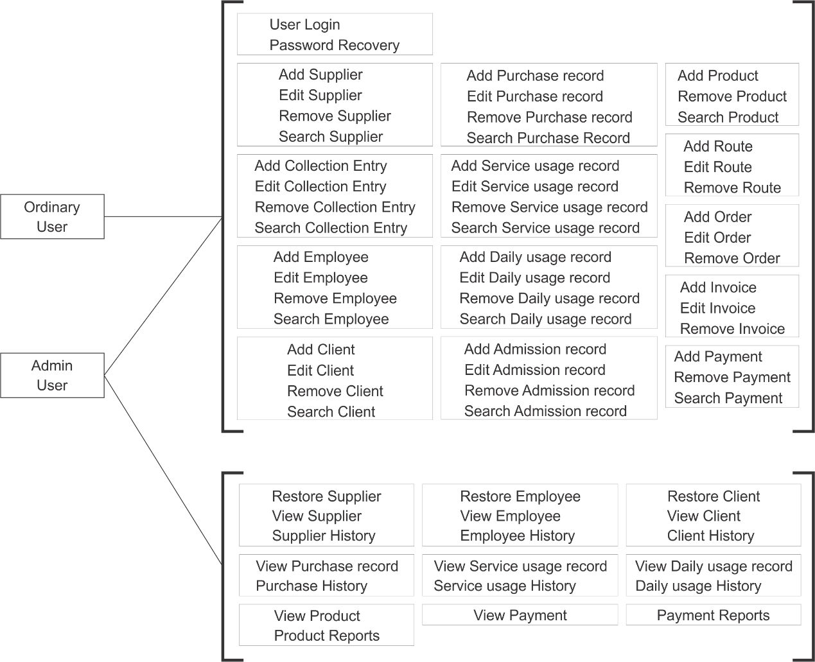

Figure 18: Functional Requirements- User Access

### 2.2.2 Level 0 DFD (Overview Diagram)

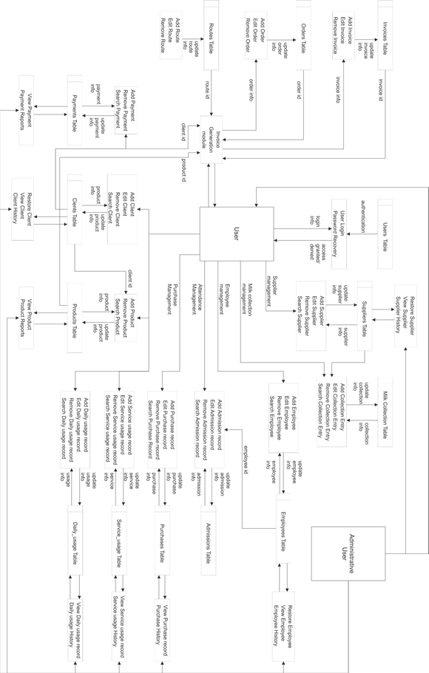

Figure 19: Level 0 DFD diagram

## 2.3 Chapter 2 Conclusion

The secret to system success is the correct organization of its data. If the data are organized so as to minimize redundancy along the lines of the structure of the business, normal changes to that business will not require significant changes to a system based on those data. Achieving this resiliency in the face of constant business change has been the holy grail of the computer industry for many years. It can be done if requirements are defined in terms of a clear understanding of the inherent structure of the enterprise's data.

The secret to winding up with the right organization of data in a system is to understand how different players view it. The system design must not only accommodate all the different external (business owner's) views that are initially understood, but it must be structured so that it can accommodate future views as well. This is possible only if the underlying, fundamental structure of the data is understood. Hence it is necessary to translate from the external schemata to a conceptual schema, before using this conceptual schema as the basis for database design.

Chapter 3

**System Design**

# 3.0 System Design

System design is one of the major phases in the SDLC process. Therefore, the GUI design and database design will be carried out here.

## 3.1 External Interface requirements

Since this bookkeeping application is simply designed for the use of clerks, managers and CEOs of a specific company, some terminology used in the application may not make sense to the general public. The interface design also had to mimic the existing physical bookkeeping system so that the user would not have to go through a tough learning curve. Although this is used by trained staff, since this is a medium sized company, the staff is not much mature and experienced so there could be some mistakes such as deleting a client. This will not be big problem because an admin level user can always restore a deleted record since it is not actually removed from the database even if a button in the UI says "Delete".

For the sake of easy understanding and explanation, each and every element is not described here but all the various types of elements, features and effects are described with examples of fundamental elements.

### 3.1.1 User Interfaces

#### Login page

Login page is displayed to anyone who tries to access the website. The login form is simply designed and contains only the User ID and Password input box.

#### Navigation bar

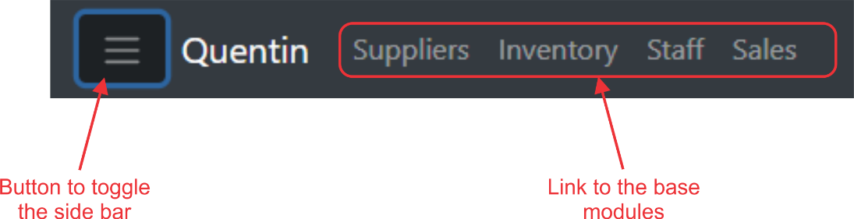The navigation bar is displayed at the top of every page so that the user can navigate to any basic module in the website such as "Suppliers", "Inventory", "Staff" and "Sales". By default, the "Suppliers" module is opened initially. The navigation bar holds a button to collapse the side bar of every module and at the right side of the navigation bar, information about logged in user is displayed.

Figure 20: Navigation bar elements

Figure 21: Navigation bar

#### Side bar

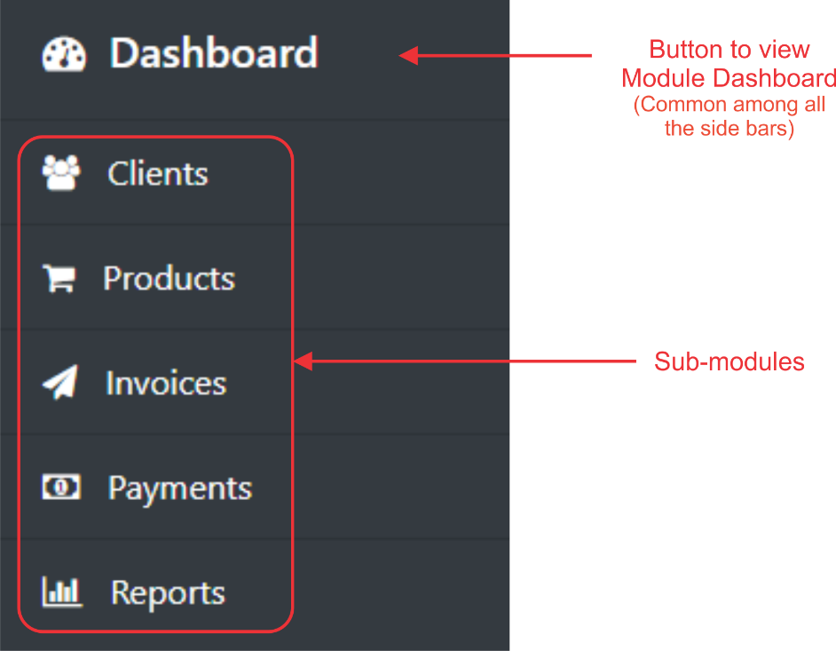The side bar contains sub modules which are specific to the selected base module. Every base module has its own dashboard so that typical informative data about that particular module can be examined. Therefore, "Dashboard" is at the top of every side bar. Other are navigation buttons to navigate the user to specific sub modules of the selected base module. For example, the "Sales" module's side bar contains, "Dashboard", "Clients", "Products", "Invoices", "Payments" and "Reports". Each of the modules contains elements which are specifically designed for that sub modules task.

Figure 22: Sidebar elements of Sales module

#### Dashboard

The dashboard consists of many elements such as graphs, charts and tables which contains many summarized data about a selected base module. The user can interact with the elements by clicking and hovering mouse over them but the user can not change or update any of the information displayed, but clicking on a particular set of data would take the user to the specific sub module which contains the clicked data.

The dashboard is one of the most effective ways for a decision maker to get an idea of how the things are behaving and to see patterns.

#### Tables

Tables are extremely effective way of data representation and it has been used in almost every module contained in the application and delivers a great deal of user experience.

#### Search/ Filter Records

Almost all the tables and lists contain this functionality. Typing out a word or set of characters would search and filter out the data which only contains the typed string. Only a pre-determined list of columns is scanned so that the user can filter that data effectively and efficiently specific to that table or list.

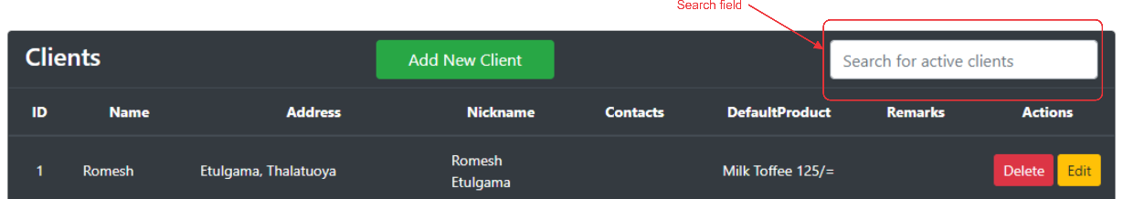Usually a search field can be found on top of a table.

Figure 23: Search field for clients table

#### Column sorting

Every column in tables can be sorted ascending or descending.

#### Table Pagination

Every table which has more than 5 or 10 records is paginated and the user can travers through pages from bottom right pagination buttons.

#### Advanced components and features

##### Date picker

This is very useful for the user when its needed to select a date. This opens a small sized calendar which highlights the current date and the user can choose any date they want. This reduces the risk of user entering "not a date" and it is easier for the user to choose a date than typing in.

##### Select picker

Select picker is another very useful component which shows the list of clients, products etc. More importantly, a single row shows multiple data about a single record which is helpful for the user to confirm that the right row is selected. Another important thing is, being able to search for data inside the field. The user can start typing on the field and only the matching rows are shown.

##### Typeahead

This component is used in numeric fields when there are frequently entered values, so that the user can either continue to type or choose from the list. This field allows the user to type any numeric value they want or use a suggested value.

##### Realtime calculations

Realtime calculations are solely happened in the front-end and those values are not stored in the database or anywhere. Therefore, the calculations are almost instant and only purpose is to give the user an idea about a calculated value.

For example, in the invoice module, when the user selects a product and quantity of the product, the amount which is calculated by (unit price * quantity) is put into the amount field.

##### Realtime row addition

There are some input forms where the user needs to insert data with using a single form for every record. This way of data entering comes in handy when there are multiple records to be added with little differences.

When the user finishes adding data to a row and needs to add another row to the table, usually the information in that row is processed, and transferred to the database before adding the new row. But that method takes time to add a new row and the user would have to be waiting until the backend process is being done. But the Realtime row addition stores the row data temporarily then submits all the table data to the database at the end of user interaction. Which results in better user experience and very less network usage.

#### Modal Dialogs

Modal dialogs are the ones which opens above the existing page in order to show/ edit detailed information about a chosen element such as a client, product etc. These modal dialogs can contain all the elements described above and this helps the user to focus on the information and gives the user impression/ visual cue, that the displayed information has a different combination from the previous page.

#### Visual Ques and effects

The UI is designed to give the user a special awareness inside the page so that he gets an idea where to look and what to do next subconsciously. Effects like button hover effects, toggle on off buttons, collapsing and expanding menus helps to give that impression better. Also, the response speed and animation speed are adjusted to give a better user experience.

The application has a high contrast dark mode theme and it cannot be changed soon.

### 3.1.2 Hardware Interfaces

A part from a working computer system and an internet connection, using a printer is suggested as an external device for printing reports and invoices.

### 3.1.3 Software Interfaces

Any updated web browser can run the application but this has been tested only in Google Chrome. No other software is needed.

## 3.2 Entity Relationship Diagram (ERD)